Asia Fruit Logistica 2024 Installation, Promotion, Operation Service Proposal Request
1. Expo Overview
◦ Expo Title: Asia Fruit Logistica 2024
◦ Duration: September 4th, 2024 (Wed) – 6th (Fri) / 3 days
◦ Location: Asia World Expo
◦ Scale: 36,000㎡
◦ Held by: Global Produce Events Gmbh(GPE)
◦ Items: Fresh Fruits and Vegetables
◦ Nature of the Expo: Held by Global Produce Events Gmbh(GPE) since 2007, it is the biggest Fresh Food B2B expo in Asia.
◦ 2023 Performance: 700 businesses from 43 countries / 13,000+ visitors
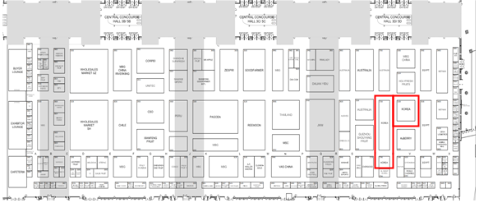 | 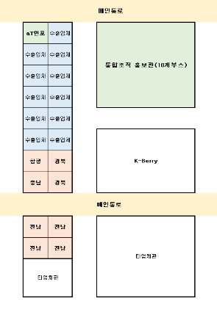
Booth Location | Detailed booths

2. Installation for the Korea Pavilion
□ Korea Pavilion Overview
◦ (Purpose) By participating in Asia Fruit Logistica 2024, we endeavor to expand the export of Korean Fresh agricultural products and excavate promising items.
◦ (Scale) 280m² (30 booths, 171m² for exporting businesses / 9m² for aT Info-desk with product display / 100 m² for Integrated Organizations)
◦ (Items) fresh food including Strawberries, Grapes, Mushrooms, and Mandarins etc
◦ Focus
- Provide the motives of expanding the export by keeping the increasing export growth of Korean fresh agricultural products and expanding export through excavating agricultural products that can lead the export in the future
· Provide participating businesses an opportunity to promote and sample their products at aT Promotion Hall and advertise marketability of Korean agricultural products through recipe suggestion and tasting using the products from the participating companies
- Secure Korea Pavilion’s competitiveness through satisfaction survey and result of consultation with the participating businesses
· have staffs responsible for surveying the satisfaction of the participating companies to secure the competitiveness of the Korea pavilion to set the trend.
- Promote rising exportable agricultural products of Korea proactively to the import buyers and distribution companies in Hong Kong and Asia through hosting consultations.
· The agency is to inform the list of exporting businesses and their participation items to the buyers beforehand, designing consultation by inducing a match between buyers and the exporting businesses during the expo.

□ The Scale of the Korea Pavilion: 280m²
Kind | Booths | Scale(㎡) | Note
Exporting Business Hall | 19 | 171 | 9㎡ / per business  (Standard & Open booth)
Integrated Organizations | 10 | 100 | Appox. 9㎡ / per business (open booth)
Information Desk | 1 | 9 | aT promotion hall, product collection hall,  food demonstration and tasting
Total | 30 | 280
* The size of the booths can be changed as the design unfolds and the local circumstance change
□ Designing and Installing of the Korea Pavilion
❍ Redesign the aT expo standard design according to the size and the structure
❍ Adequate spacing to improve the exhibition and consultation effect and design inspired by carpentry
❍ Maximize the visual impact by applying modern, sensual, and polished design emphasizing the Korean image and decorate the space with equipment related to the Korean agricultural products and food culture
❍ When bidding for the equipment service, application and field management of, and calculation for the additional equipment (extra electricity, refrigerating facilities, sampling related equipment, etc.) will be done at once. The aT Information Desk shall be designed including the information function, Collection Hall for the Miracle items and the items from the participating businesses, and sampling area.
❍ The equipment business is to be in charge of all the matters of the installation service (application and approval of the construction, electricity, fire fighting, air circulating, etc.)
❍ The equipment business is to cover the application and essential utilization of the electricity (lighting, 1kW per business, etc.)
- Arrange electricity for each exporting company participating in the expo by its need.
* One or more personnel is to stay at Korea Pavilion during the expo to manage with responsibility

3. Korea Pavilion Installation Service
□ A Detailed List of the Equipment (design as a standard booth by carpentry)
❍ aT Information Desk (9㎡ / 1booth)
- Function as a business center with office supplied like PC, printer, and Wi-Fi installed
- Install big 70-inch LED TV to emit videos for advertising Korean agricultural products and for introducing participating businesses and their items

Item | Note
Consulting Table | 1 Tables, 4 Chairs *omittable for securing food demonstration area
Information Desk | 2 Bar Stool, internal storage area, locking facility, can be used also as a showcase for displaying
PC(Laptop) | 1 (with basic office programs like MS Office and Hangeul installed)
Water  Dispenser | 2(including 10 bottles of mineral water), 300 paper cups
TV | 1 70 inch LED TV (USB applicable, wall-mounted) & HDMI cable
Poster | Promotion poster, including a frame and lighting
Lighting | Mix SPOT and LED Footlight (of HQI) adequately (one or more lighting per panel)
Widecolor | 2 kinds of light boxes, 100cm×120cm or bigger
Internet | 2 lines (1 for PC, 1 for Wi-Fi)  Reuter (wired and wireless, Wi-Fi available, password applied)  Install so that the participating businesses can join massively
Storage | With entrance and locking utility
Sub-ornaments | 3 Catalog stand, 3 set of desktop national flags(Korea, Hong Kong), Korea Pavilion general information map
Others | 1 trash bin, 60 trash bags, 4 4-socket outlets, dishes and forks for tasting

❍ Exporting Businesses Hall (171㎡/19 booths)
Item | Note(Detailed list for each booth)
Business Sign | with logo and lighting (300watt or more)
Exhibition  Stand(front) | 3-level show case, with lighting and locking facility
Information  Desk | Sampling zone, internal storage, locking facility, with logo
Table Set | 1 table, 4 chairs
Exhibition Stand  (Back) | 1 stand (with internal storage area and locking facility), posters
Stand | Mix SPOT and LED footlight (or HQI) adequately (one or more lighting per panel)
Outlet | 2 sockets, offer 1kw by default (add additional electricity for the businesses applied for 24 hour electricity)
Catalog Stand | 1 stand
Desk National Flags | 1 set
Other  equipment | 1 Trash bin
Internal  Storage | one per booth, with door stopper and locking facility installed
- standard booth, one-side open with a wall at the back and separators(left and right)
- exhibition, sampling, export consulting, distributing of the brochures (catalog, etc.)
- gather the logos from the businesses and get final confirmation with the person in charge
- total of 19 booths — 19 for aT exporting businesses— are to be made as standard booths, where consult with buyers and sampling will be held
- check the additional demand from the exporting businesses individually and reflect the equipment and logo after confirming the booth and installation company
*Details to be negotiated after selecting a service company

❍ Integrated Org. Hall (100㎡/10 booths)
Item | Note(Detailed list for each booth)
Business Sign | with logo or lighting (300watt or more)
Exhibition  Stand(front) | 3-level show case, with lighting and locking facility
Information  Desk | Sampling zone, internal storage, locking facility, with logo
Table Set | 1 table, 4 chairs
Stand | Mix SPOT and LED footlight (or HQI) adequately (one or more lighting per panel)
Outlet | 2 sockets, offer 1kw by default (add additional electricity for the businesses applied for 24 hour electricity)
Catalog Stand | 1 stand
Desk National Flags | 1 set
Other  equipment | 1 Trash bin
Collection Zone | Organize a collection zone in the middle

- Open booth
- exhibition, sampling, export consulting, distributing of the brochures (catalog, etc.)
- gather the logos from the businesses and get final confirmation with the person in charge
- total of 10 information desk(Wooden) where consult with buyers and sampling will be held
- check the additional demand from Integrated Organizations individually and reflect the equipment and logo after confirming the booth and installation company
*Details to be negotiated after selecting a service company
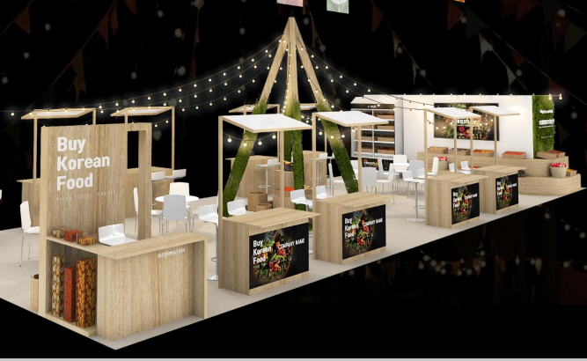 | 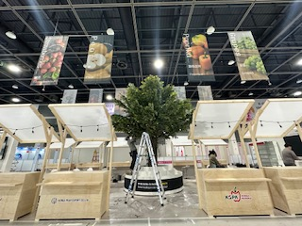
Integrated Organization Hall examples

❍ Others
- One additional set of ceiling banner *can be deleted if the host does not allow
· additional banner than the basic banner offered by the host
· keep consistent with the overall design of Korea Pavilion — design should be checked and agreed beforehand
· standard size can be adjusted according to the installation rule — installation place must be agreed
- cleaning of the pavilion: clean the entire pavilion for the entire event period (3 days) (once per day)
- including the cost followed by using outlet and electricity as installing the pavilion
- the aforementioned is an essential requirement — aT and the equipment business may edit or add partially through negotiation
- make a polished look by having a separate plan for the lighting of the pavilion
- submit photos and videos taken during the event when reporting
- the personnel in charge from the installation company shall remain at the Korean Pavilion during the event period to manage with responsibility
· the condition is that it includes everything from manufacturing to transportation, installation, management, and disassembling
- the equipment business is to calculate with the participating companies for the additional equipment
* be in charge of related businesses of refrigerating products including providing price list and equipment, collecting applications, installment and change of the products on site, retrieving
- When GPE decides to postpone or cancel the show, the contract on this service may be delayed in completion date or cancelled.
- Submit final floor plan including 3D blueprints 2-3 weeks before the expo
Field | Floor Plan Required
3D | Perspective, Front View, Side View
Layout | Top View, Human Traffic Plan, Per-Kind Arrangement Plan
Information Desk | Perspective, Front View, Top View
Exporting Business Hall, Other Businesses | Perspective, Front View, Side View
Graphic Printing Material | Business Logo, Information Map, Banner, Wide Color, etc.
* Submit the above as PDF and CAD file via e-mail or with USB

4. Korea Pavilion PR Service
□ Media Promotion and Sending out Invitations to the Buyers
❍ Advertise Korea Pavilion and distribute a release press copy through influential newspapers and food-focused press
❍ Distribute buyer invitation, promotional pamphlet, etc. with local large-scale distributer and buyers
❍ Provide information about the participating businesses and lead to a match
□ Design a banner for Korea Pavillion for Online Promotion
❍ Design a banner to put on Official website of Asia Fruit Logistica 2024 and enter individual company’s product information on the website.
❍ Design a hanging banner.

5. Korea Pavilion Management(Operation) Service
□ Support the Expo Management through Supporting Korea Pavilion and the Participating Companies
❍ guide and support with the requests of the participating companies (interpretation, additional equipment, transportation, etc.)
❍ Collect representative products from the participating companies and display on the collection zone
❍ Distribute and collect the daily consulting log for the participating company organize the collected log right after the show(have one staff in charge of)
❍ Enact satisfaction survey for the participating companies (have one staff in charge of)
□ Recruit 2 MDs for Information booth and 2 MD for the Integrated Org. Hall
- Recruit and educate MDs to consult with buyers on behalf of exporting companies(Bilingual : Korean and Chinese)
- Let MDs to record consulting log everyday for each exporting companies they are in charge of
□ Other Overall Proxy Works Managing the Korea Pavilion
□ Check with the Individual companies about any operational information of the exhibition and inquiries about Interpretation Staffs(MDs)

4. Service Contract Fee Provision
□ Budget amount : 219,000,000KRW
□ Prepayment (if requested)
❍ While the prepayment is not provided by principle, if the service providing business submits documents that guarantee the fulfillment of the prepayment such as guaranteed securities from a financial institute of banks, insurance companies, etc., the prepayment can be provided.
❍ Provided within three weeks since the request after the contract (within 50% of the contract fee)
□ Service Fee (remaining fee): when the service company submit the final report within the contract period, the corporate will finish checking within 14 days and pay the service fee (remaining fee) within 30 days

5. Assignment Submission
□ Assignment Final Report
❍ Submit with related documents within the contract period (within a month after the end of the event)
* assignment progress shall be reported on demand

□ Proposal Submission
❍ Bidding Period: 2024.6.27.(Thr) ~ 2024.7. 8.(Mon) 18:00 pm
❍ Submission Deadline : within the announcement period
❍ Submission method: via e-mail to the person in charge of aT Hong Kong branch (hjk@at.or.kr)
❍ Documents to Submit : proposal and company introduction (including general status, human power deployment plan, performance for the last three years, certificates for the achievements, etc.)
* Please do not include your company name and logos in the proposal.
* For the price estimate , do NOT include in the proposal, and send it separately through above mail so that it can arrive at the Hong Kong branch office within the submission period (only the price estimates arrived by 10:00am of the deadline will be applied to the evaluation)

Evaluation Criteria for AFL 2024 Korea Pavilion Installation, Promotion, Operation Service Proposal

◦ Subject | Asia Fruit Logistica 2024  Korea Pavilion Proposal | ◦ Evaluatee
◦ Evaluation Date | 2024. 7. . | ◦ Evaluator | (인)

 | Criteria | Evaluation details | Points
Technical Compatibility  (80) | Planning and Concept  (20) | √ Suitability with purpose  √ Completeness of project contents | 20 | 18 | 16 | 14 | 12
Technical Compatibility  (80) | Capability  (20) | √ Originality of Korea Pavilion layout  √ Management plan for Participationg companies  √ Recruitment of suitable MDs(Translators) | 20 | 18 | 16 | 14 | 12
Technical Compatibility  (80) | Technical Ability  (10) | √ Punctuality management  √ Technical System suitable to operate the business | 10 | 9 | 8 | 7 | 6
Technical Compatibility  (80) | Human Resource  (10) | √ Suitability with manpower  √ Past performance | 10 | 9 | 8 | 7 | 6
Technical Compatibility  (80) | Korea Pavilion Promotion  (10) | √ Adequate plans for Buyer recruitment  √ Feasibility of Korea Pavilion promotion plans | 10 | 9 | 8 | 7 | 6
Technical Compatibility  (80) | Safety Management, After Service  (10) | √ Safety Management Plans  √ Feedbacks and after service | 10 | 9 | 8 | 7 | 6
Bid Price  (20) | Calculation  (20) | “Bid Price Equation” as defined in  “Criteria for Contracts by Negotiation (Korea)”
Total (100)

